Weekly reports are to be emailed to atbecker@uh.edu by 5:00pm on Tuesdays. The purpose of a weekly report is to: (1) give you text and images for your papers, thesis, and dissertation, (2) document progress, (3) identify if you are stuck or need resources.

Weekly report

1. **My *Goals* from last week**

* Test ways to mount servo motors to tilt table.
* Learn how to control tilt table with MATLAB.
* Test ideas for magnetic mating sliders.
* Make 2x1 passive sliders.

1. **My *Accomplishments* this week**
   1. Project 1: <Make 2x1 passive sliders>

* For this I managed to repurpose the existing 2x1 sliders and make them work on my 15x9 Tilt Table with minimal modifications.

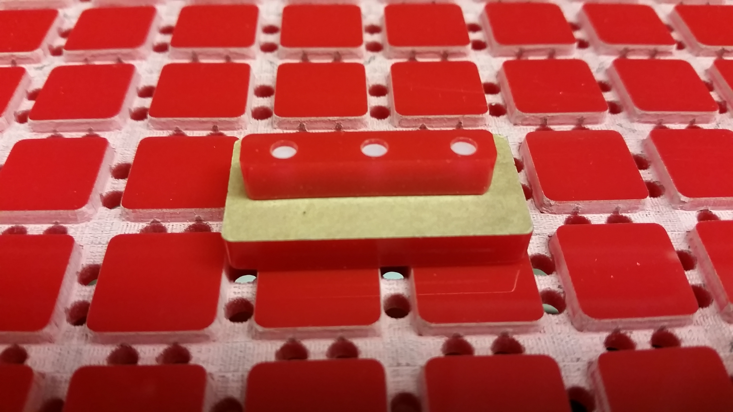

**Figure 1:** 2x1 passive slider resting on 15x9 Tilt Table.

* 1. Project 2: <Control 2 Servos with MATLAB>
     + Using the Arduino Mega that I purchased for robotics class, I was able to learn MATLAB Arduino and motor controls and power two servos simultaneously. I also wrote a short code that completes a down, left, up, right, down cycle, with sufficient pauses in between, that can be used to complete a logic gate demo.

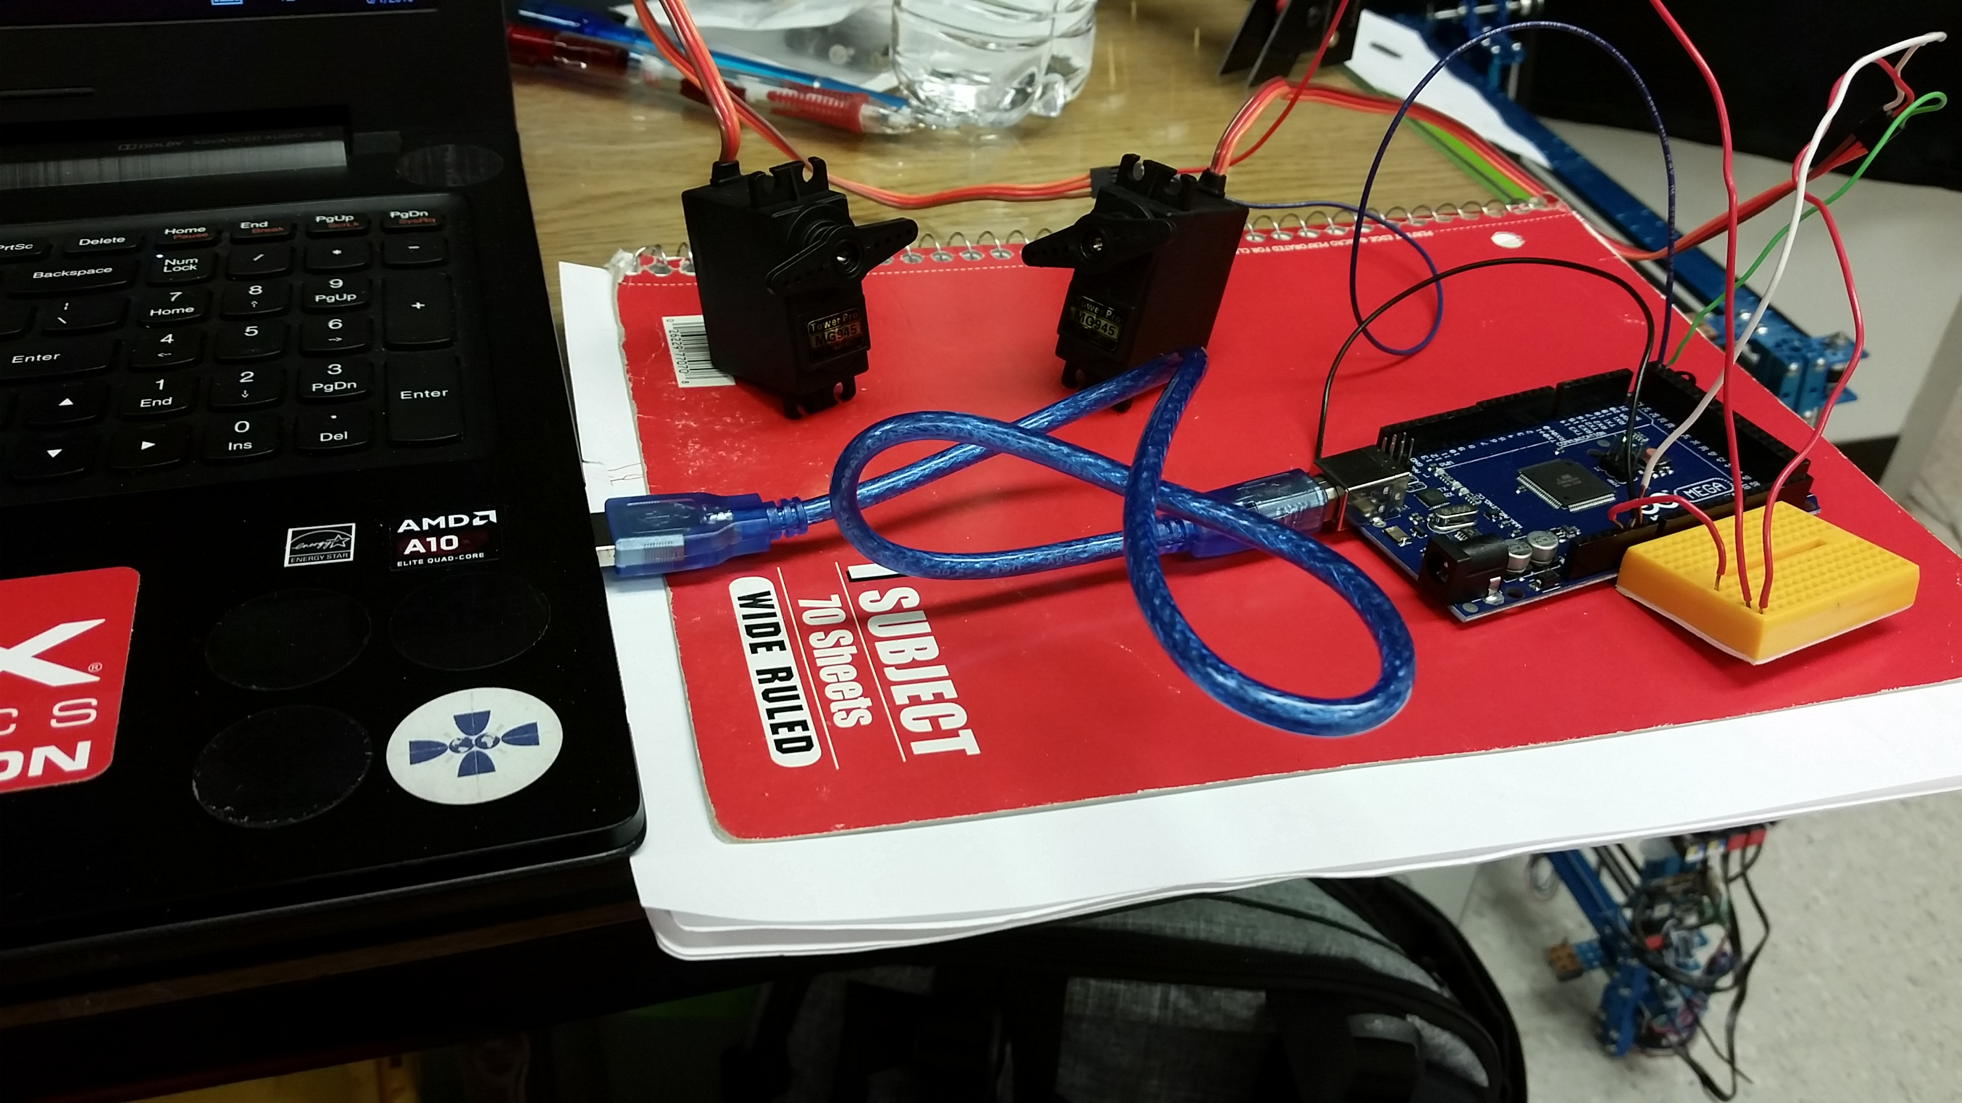

**Figure 2:** Two metal gear servos connected to an Arduino Mega.

* 1. Project 3: <Test Ways to Motor Mount Tilt Table>
     + Using google sketch up I have drawn the idea that seemed the best and have begun working out dimensions for it. To do this I also needed to find the angle at which the sliders begin to move down the Tilt Table. Using a sheet of paper to mark the angle of five trial runs, I found that the largest angle needed was 21.8 degrees. I also determined that 30 degrees is too extreme of an angle and the sliders will reach high enough speeds to jump out of their slots and off the table. Because of this I have decided to use a max tilt angle of 25 degrees and mechanically limit it to a 27 degree tilt angle.

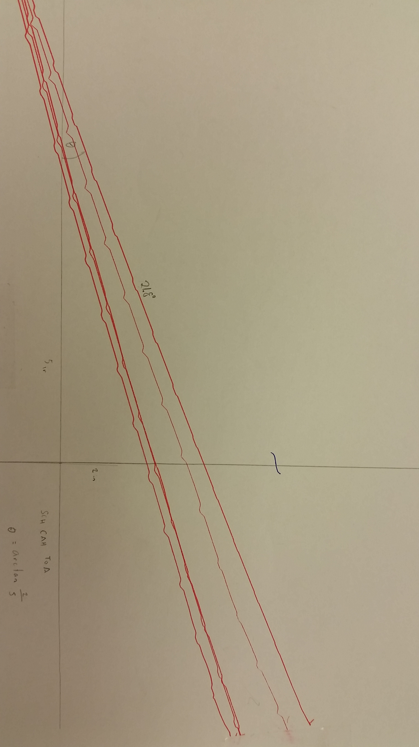

**Figure 2:** Five angle tests to find optimal angle for slider movement.

* + - The design itself is not complete yet, but it will closely resemble two half circles with one sitting inside the other, each half circle will be controlled by a servo and be responsible for movement in either the left and right directions or up and down directions. The servo controlling the up and down directions will be mounted onto the outer half circle and will control the inner half circle. The inner circle will be supported by its servo and the outer circle will be supported by a stand that has yet to be designed. The pieces will be made of acrylic with the assistance of the laser cutter and then will either be glued or screwed together.

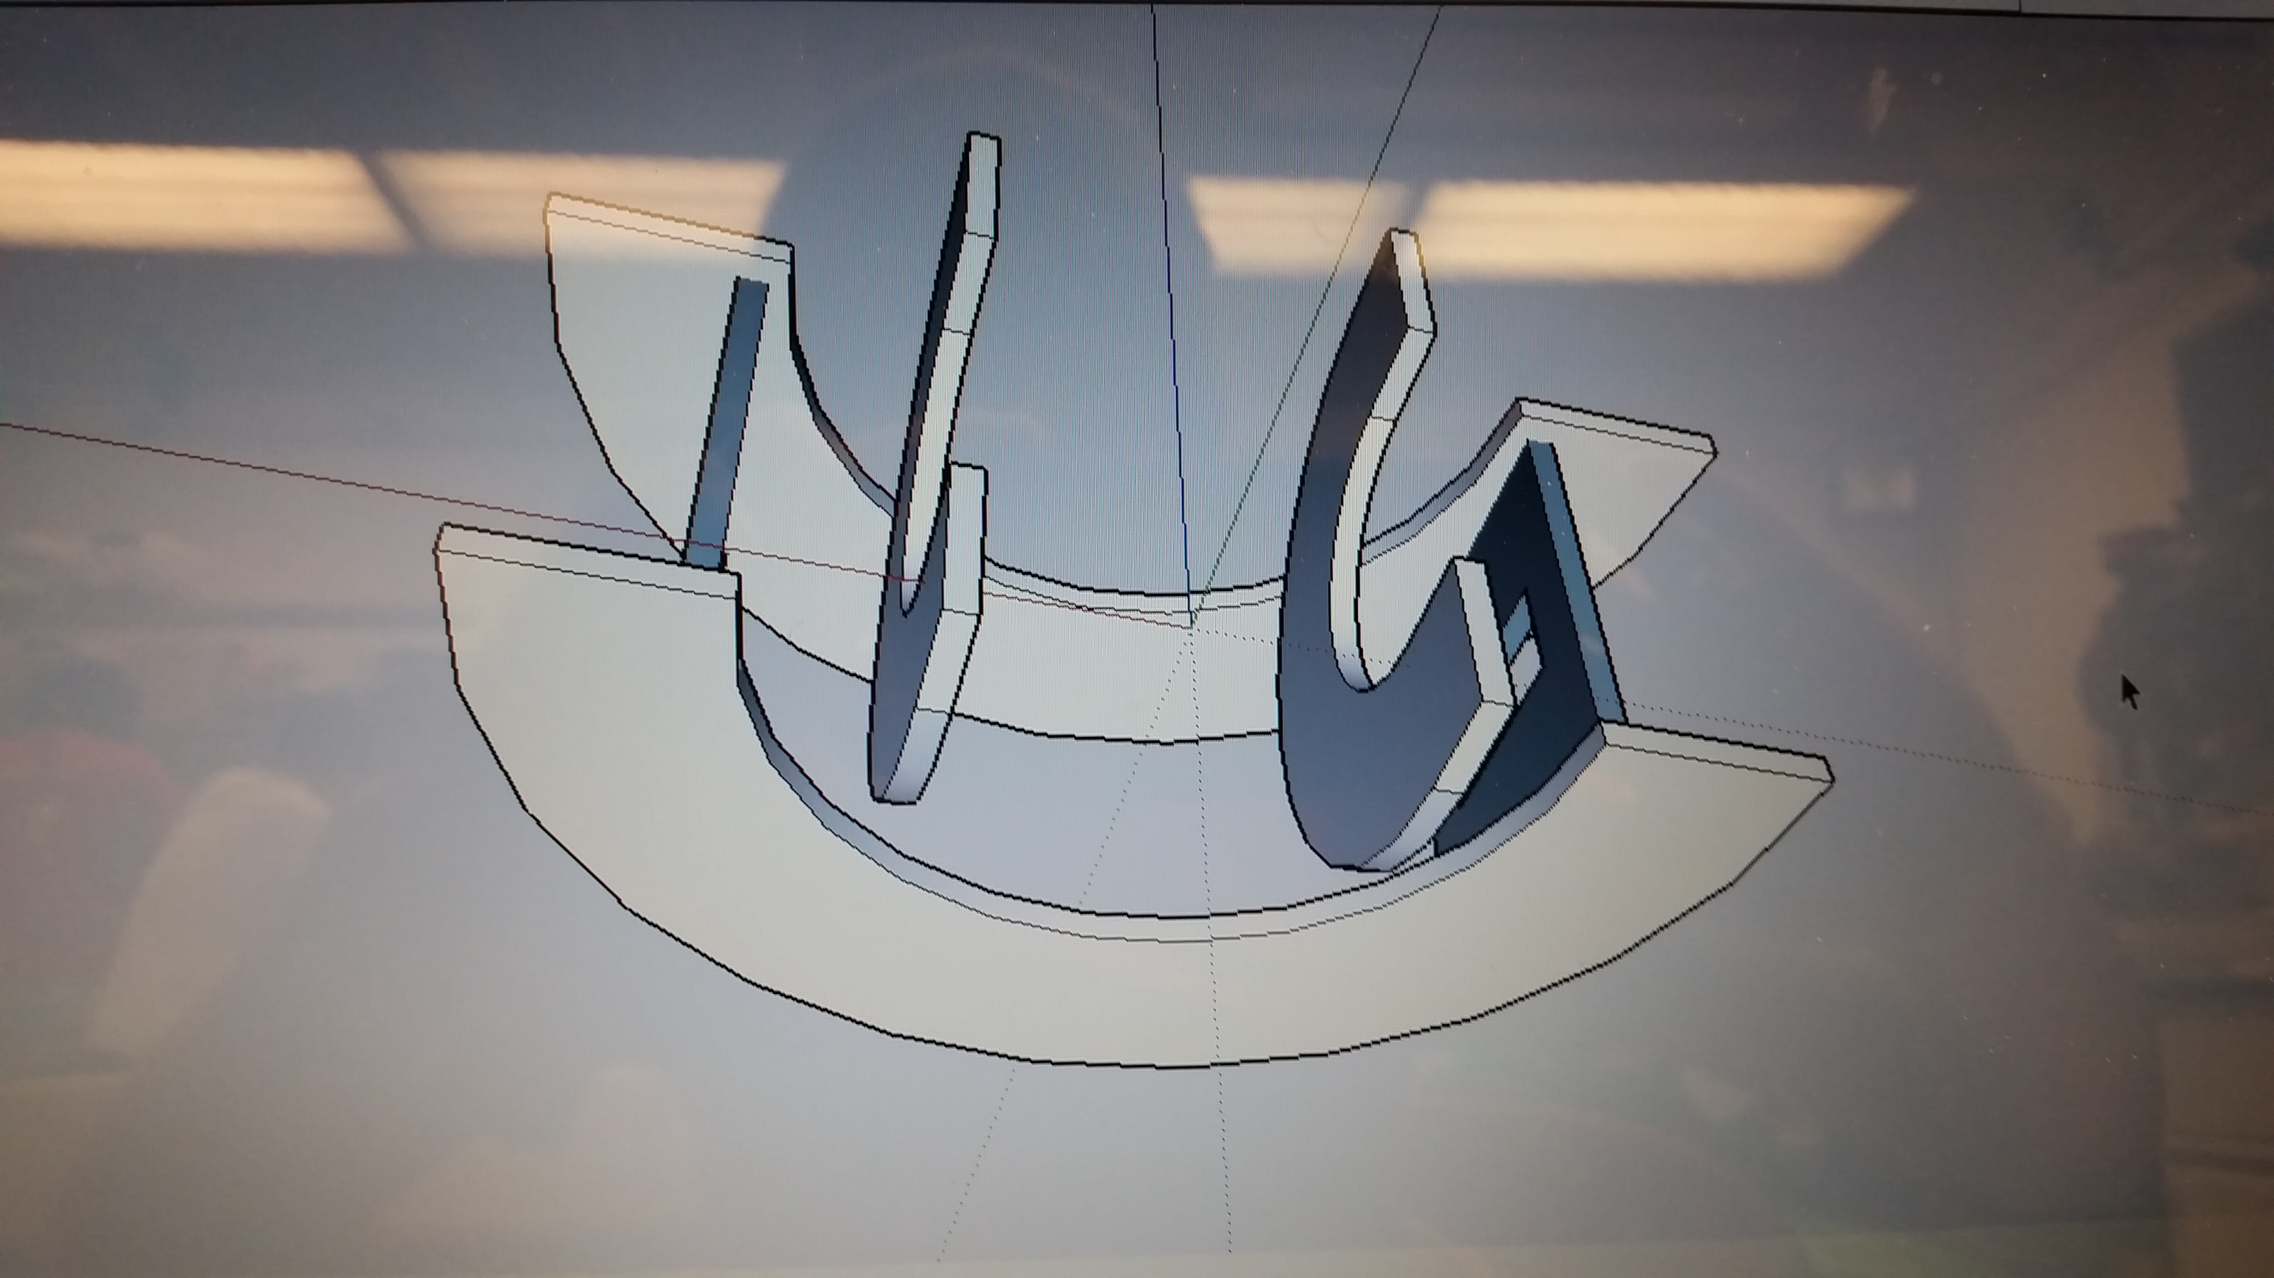

**Figure 3:** Rough draft Tilt Table Servo mount drawing on Sketch Up.

* 1. Project 4: <Vacation>
     + On Friday I took a trip to Dallas and visited Ripley’s Believe It or Not and Medieval Times, which is a place that gives you a four course meal as you watch jousting and other fun medieval things. I also had the pleasure of volunteering at a wheelchair tennis tournament in Dallas on Saturday and met many amazing people.

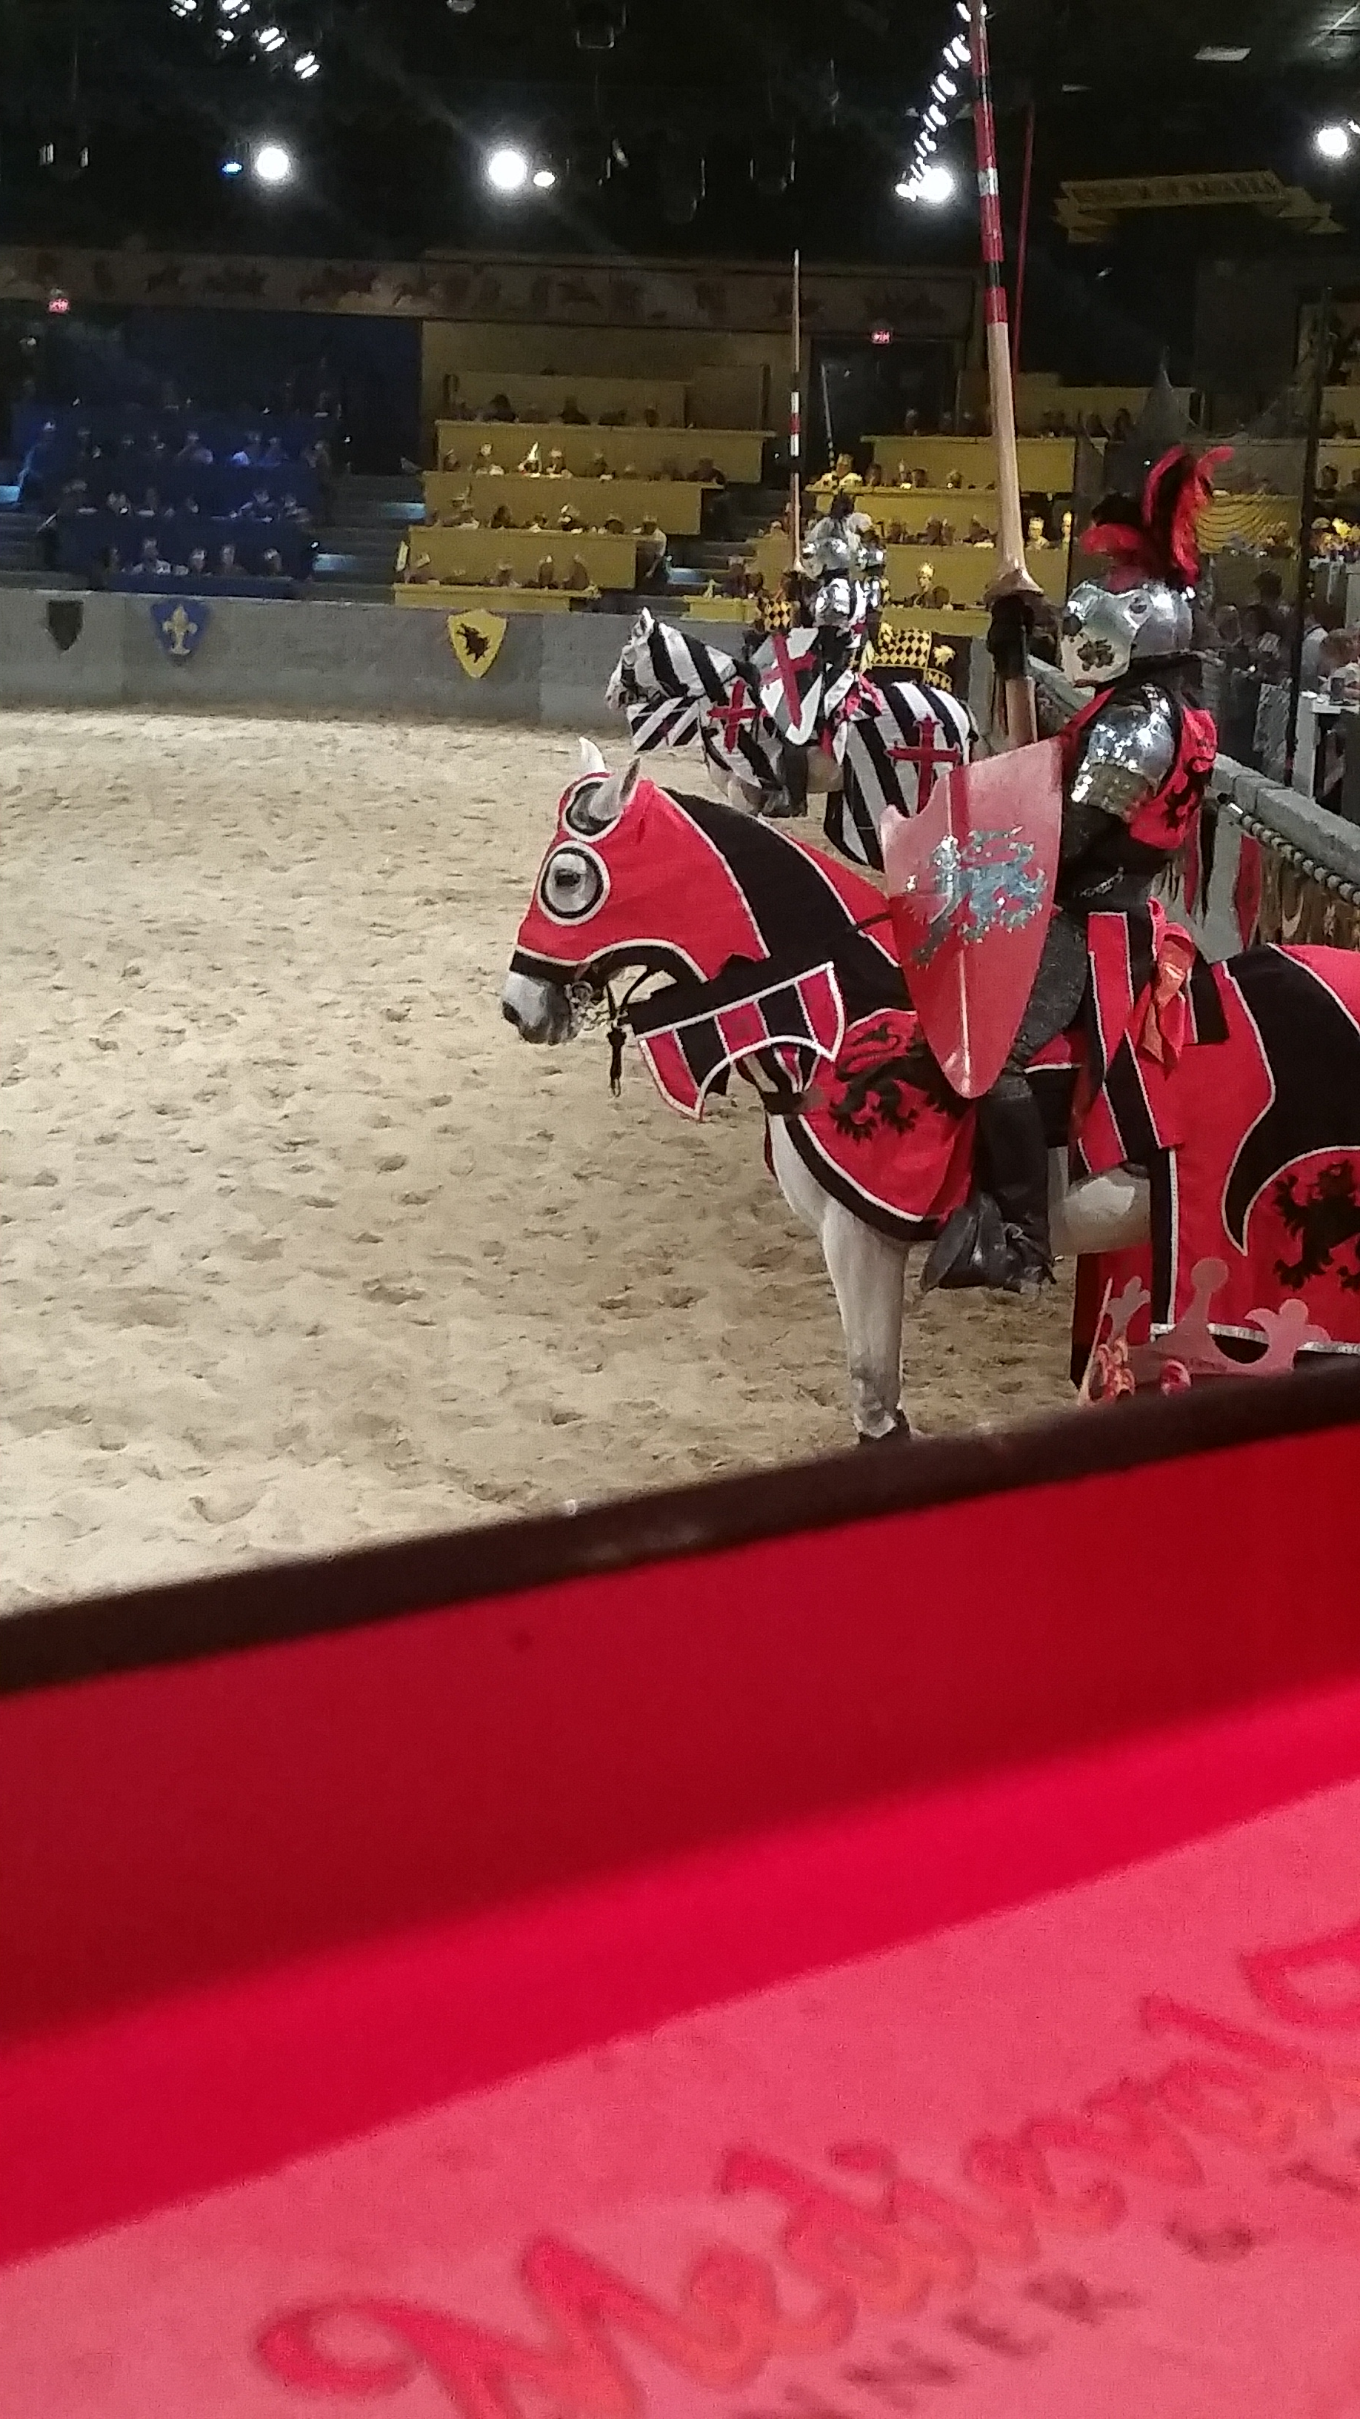

**Figure 4:** Picture of the arena in Medieval Times.

1. **My *Goals* for next week**

* Complete and test first design for Tilt Table Servo Mount.
* Test additional ideas for servo mount, if needed.
* Test ideas for magnetic mating sliders.
* Make video for a carry, summer or counter function.

1. **What I need Dr. Becker to do:**
   1. Purchase sheets of solid red, solid blue, solid white and solid black acrylic for the laser cutter.

Time Sheet: Also added to Github, not sure how to attach into word file.